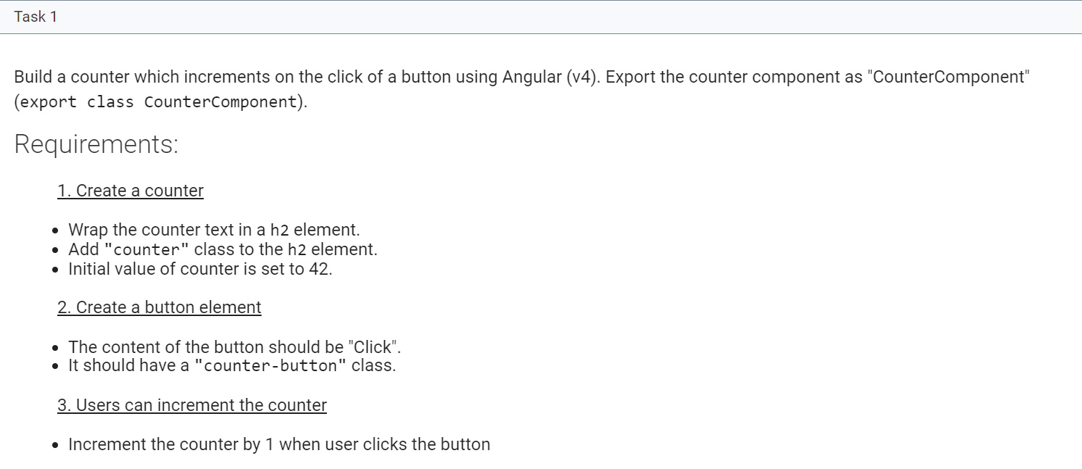

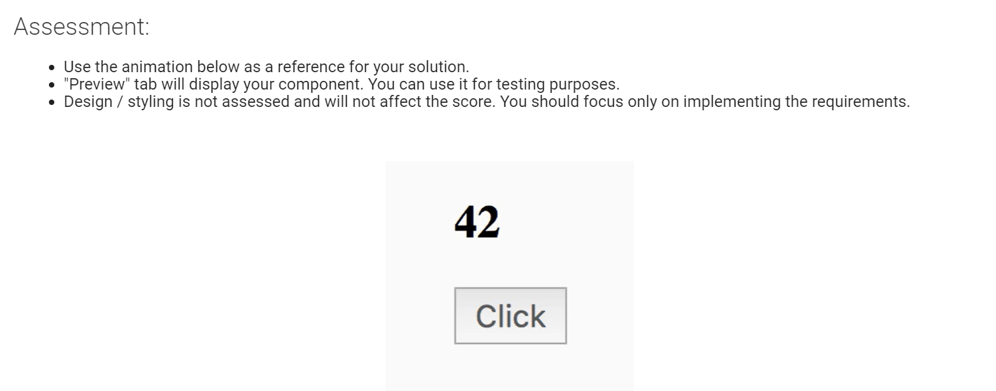

import { Component } from '@angular/core';

@Component({

    selector: 'counter',

    template: `

    <h2 class="counter">

    {{counter}}

    </h2>

    <button class = "counter-button" (click)="increment()">Click</button>

    `,

    styles: [`

        .counter-button {

            font-size: 1rem;

            padding: 5px 10px;

            color:  #585858;

        }

    `]

})

export class CounterComponent {

 constructor () {}

  counter = 42;

  increment() {

    this.counter++;

  }

}

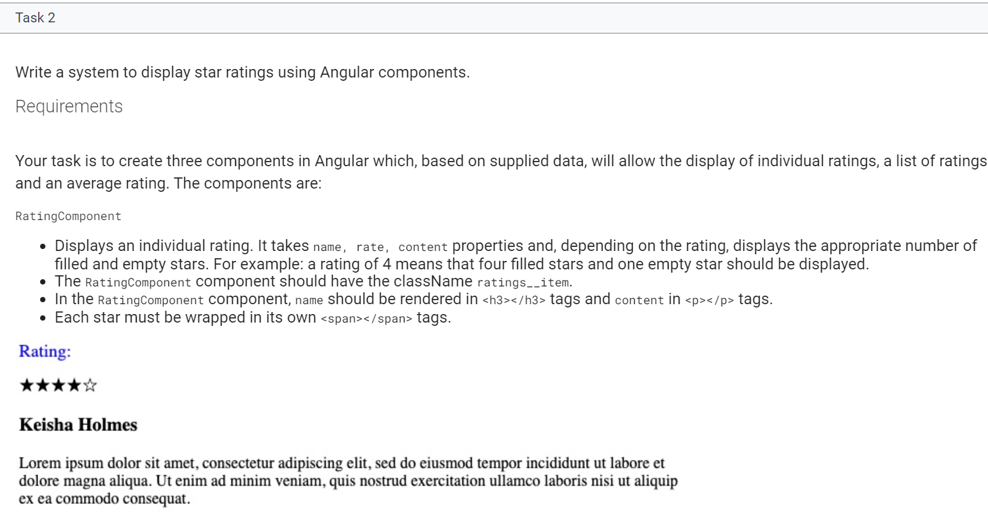

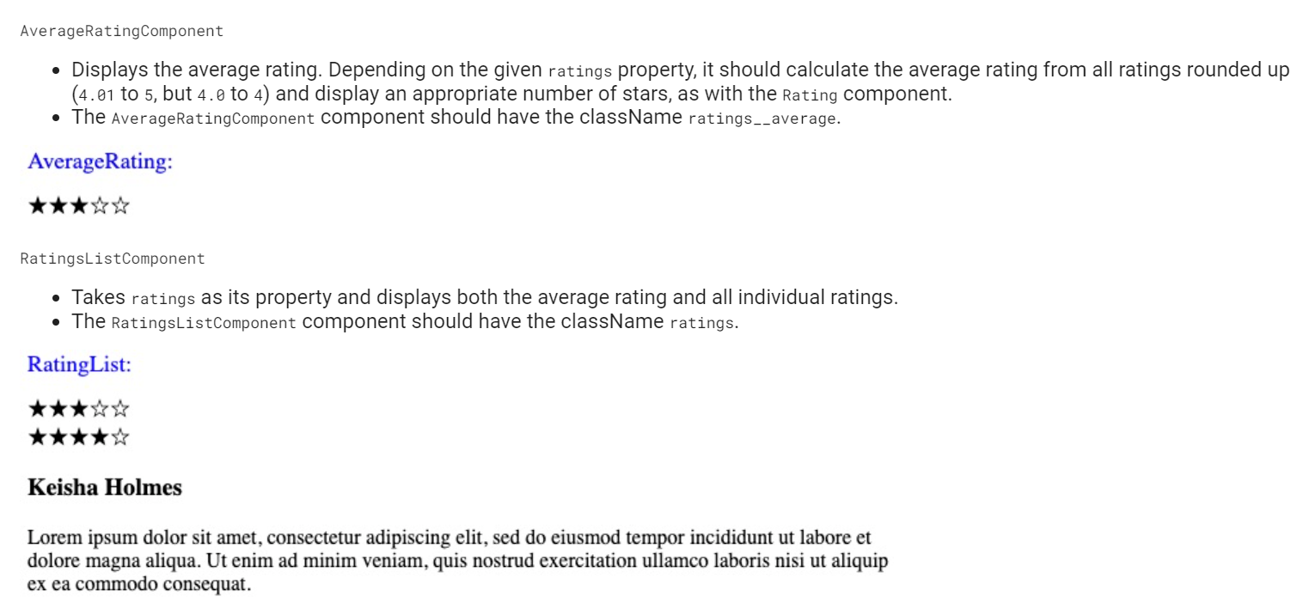

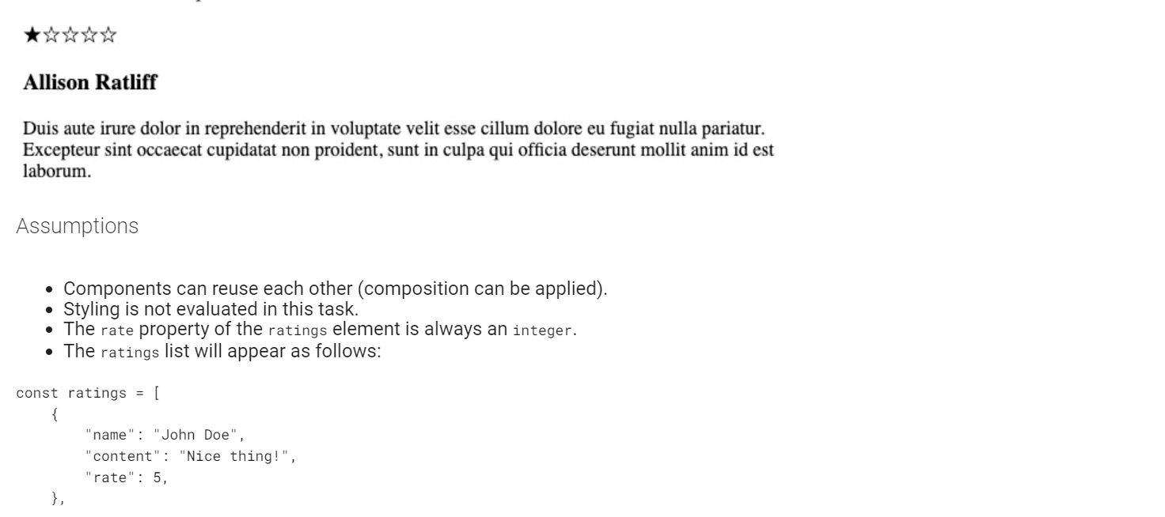

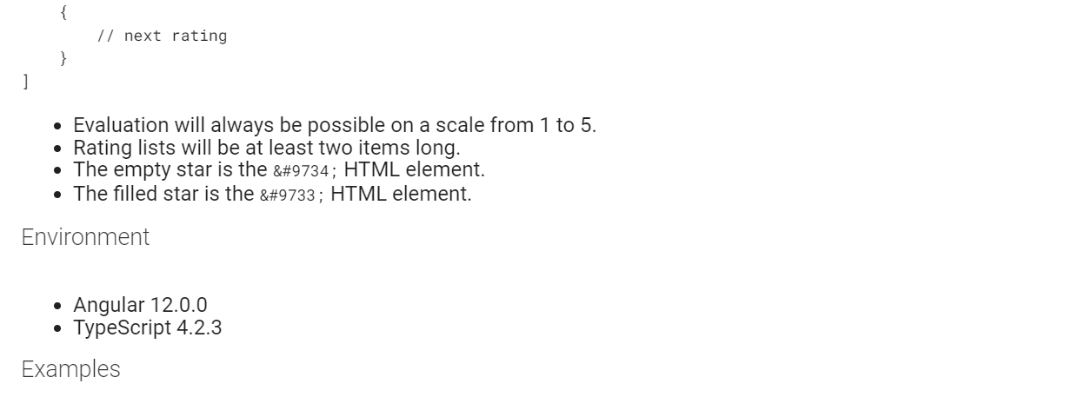

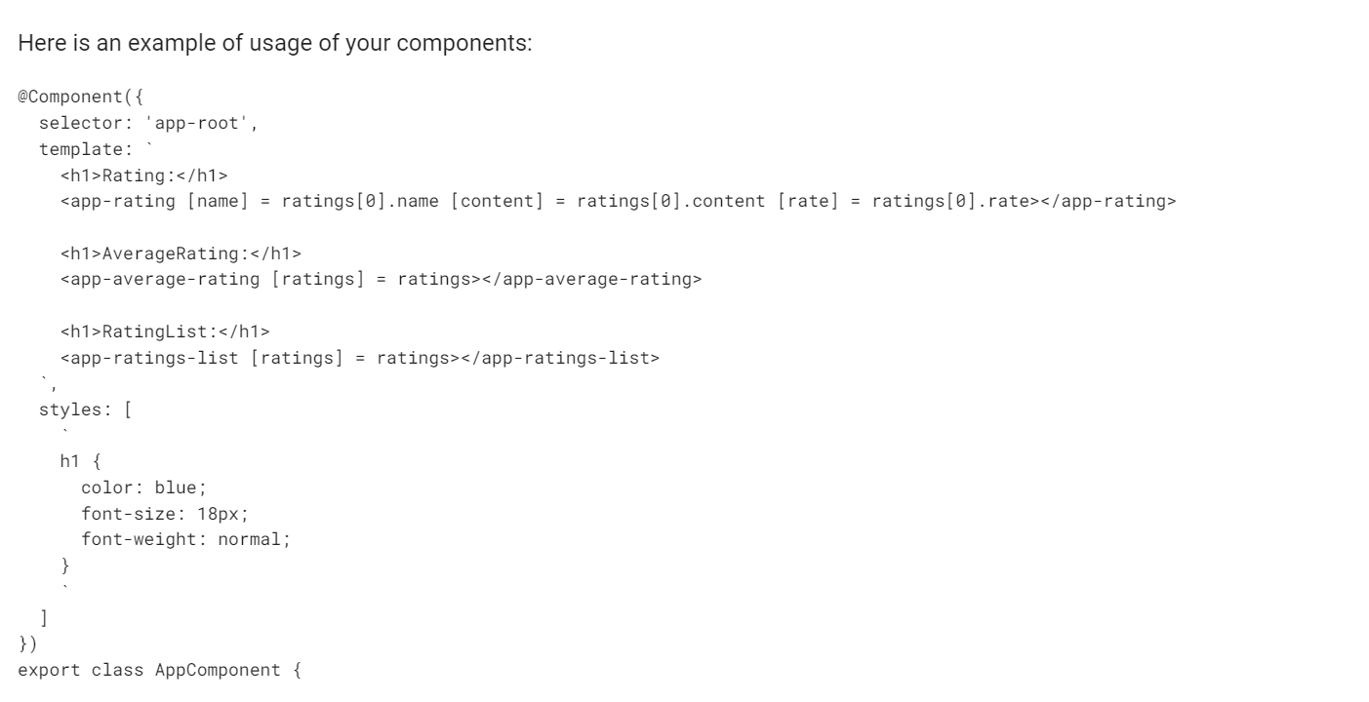

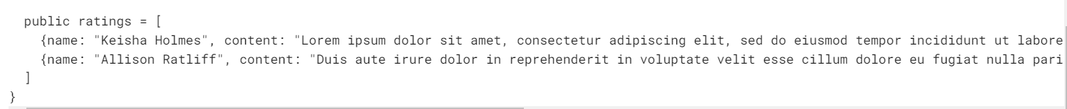

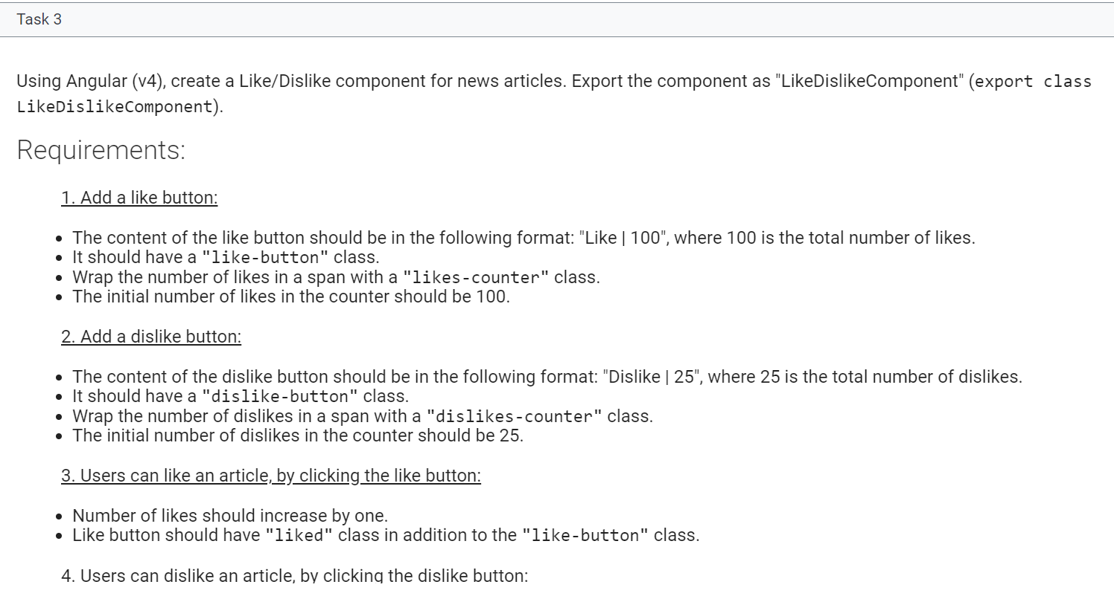

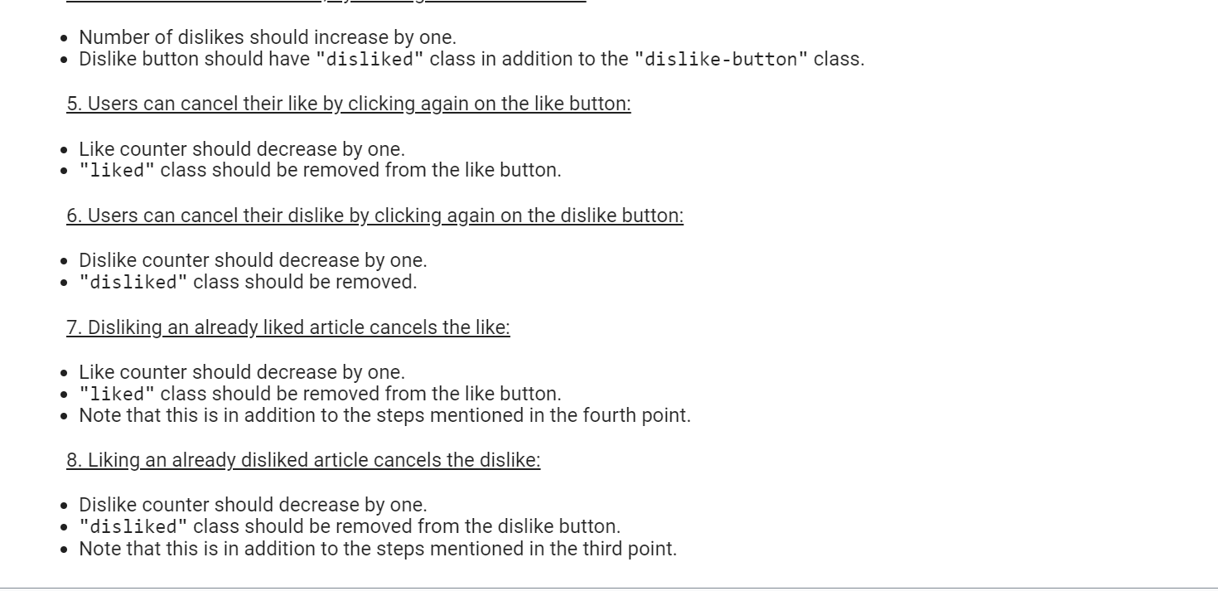

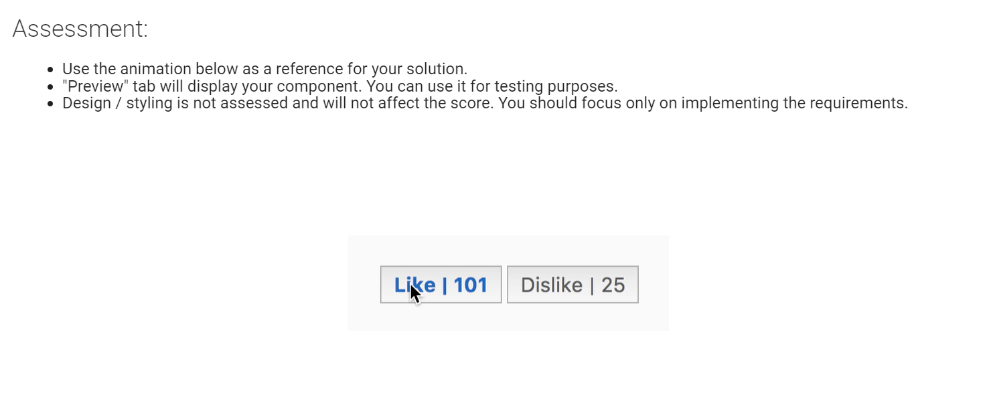

import { Component } from '@angular/core';

@Component({

  selector: 'like-dislike',

  template: `

      <div>

        <button class="like-button" (click)="likeTheButton()" [ngClass]="{liked:isLiked}">

          Like | <span class="likes-counter">{{likeCounter}}</span>

        </button>

        <button class="dislike-button" (click)="dislikeTheButton()" [ngClass]="{disliked:isdisLiked}">

          Dislike | <span class="dislikes-counter">{{dislikeCounter}}</span>

        </button>

      </div>

  `,

  styles: [`

    .like-button, .dislike-button {

        font-size: 1rem;

        padding: 5px 10px;

        color:   #585858;

    }

    .liked, .disliked {

        font-weight: bold;

        color: #1565c0;

    }

  `]

})

export class LikeDislikeComponent {

  likeCounter = 100;

  dislikeCounter = 25;

  isLiked=false;

  isdisLiked = false;

  likeTheButton():void{

    this.isLiked = !this.isLiked;

    this.isdisLiked = false;

    this.likecounterChange();

  }

  likecounterChange(){

    if(this.isLiked){

      this.likeCounter += 1;

      if(this.dislikeCounter>25){

        this.dislikeCounter -=1;

      }

    }

    else{

        this.likeCounter -= 1;

    }

  }

  dislikeTheButton():void{

    this.isdisLiked = !this.isdisLiked;

    this.isLiked = false;

    this.dislikecounterChange();

  }

  dislikecounterChange(){

    if(this.isdisLiked){

      this.dislikeCounter += 1;

      if(this.likeCounter>100){

        this.likeCounter -=1;

      }

    }

    else{

        this.dislikeCounter -= 1;

    }

  }

}

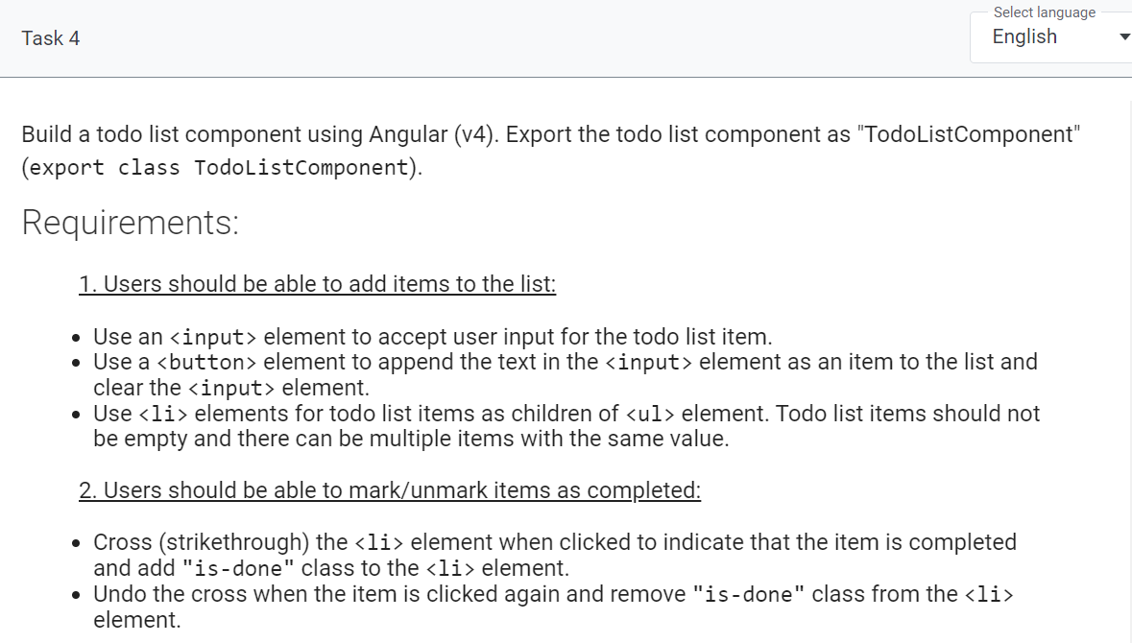

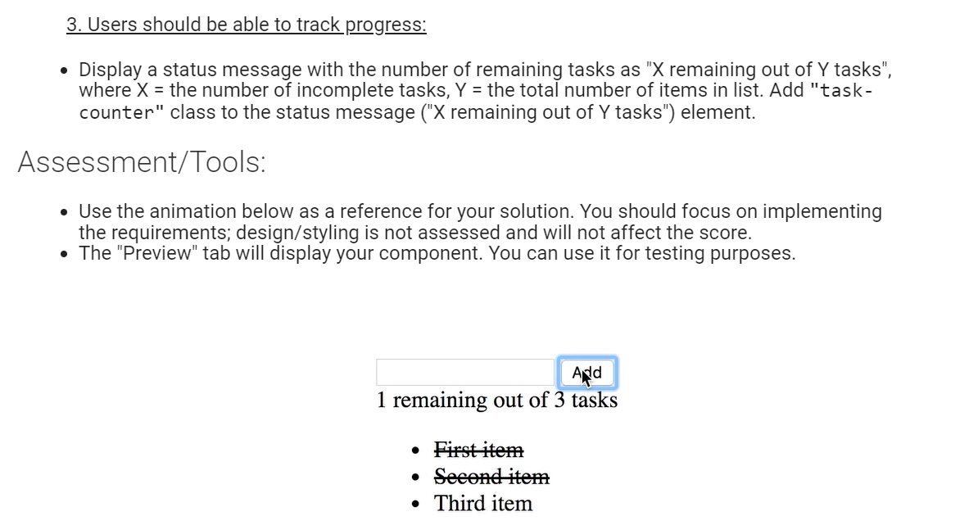

// write your code in TypeScript

import { Component } from '@angular/core';

class TodoItem {

  isDone: boolean;

  name: string;

}

@Component({

  selector: 'todo-list',

  template: `

  <input type="text" [(ngModel)]="name"/>

  <button type="submit" (click)="add()">Add</button>

  <p class="task-counter">{{x}} remaining out of {{items.length}} tasks</p>

  <ul>

    <li (click)="toggleItem(c)" \*ngFor="let c of items" [value]="c">{{c.name}}</li>

  </ul>

  `,

  styles: [`

    .is-done {

      text-decoration: line-through;

    }

  `]

})

export class TodoListComponent {

  public name: string = '';

  public items: Array<TodoItem> = [];

  flag = false;

  obj:TodoItem;

  x :number;

  public getRemainingCount() {

    return this.items.filter(item => !item.isDone).length;

  }

  constructor(){

    this.x = this.getRemainingCount();

  }

  public add() {

    if(this.name!=''){

      this.obj = {

        name: this.name,

        isDone: false

      }

      this.items.push(this.obj);

    }

    this.x = this.getRemainingCount();

    this.name = '';

  }public toggleItem(item: TodoItem) {

    item.isDone = !item.isDone;

    this.x = this.getRemainingCount();

  }}